Chapter 7: Forces

7.1 A force is a push or pull

Literacy support worksheet answers (pages 120–121)

Push and pull forces

1 Forces act on everything around us all the time. In the spaces provided, draw a labelled diagram to explain what forces cause objects to do. (Use different examples from those in the textbook.)

**Begins to move**

Student responses will vary but could include pushing a chair under a desk.

**Speeds up**

Student responses will vary but could include changing from a jog to a sprint.

**Slows down**

Student responses will vary but could include using the brakes on a car.

**Changes direction**

Student responses will vary but could include a cricket batsman hitting the ball.

**Changes shape**

Student responses will vary but could include bending a paper clip.

**Remains still**

Student responses will vary but could include a statue.

WORD DETECTIVE

2 Crossword

Read the clues below and place the correct answers in the crossword boxes.

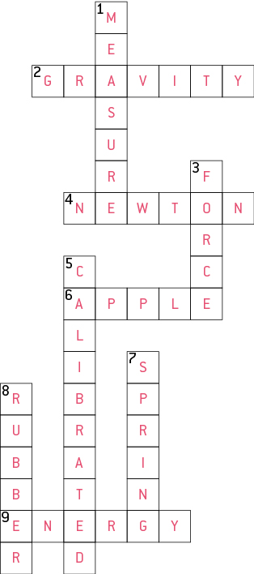

etc.) and on the equipment used (footwear, bats, racquets, ball, padding etc.).

7.2 An unbalanced force causes change

Literacy support worksheet answers (pages 122–123)

Balanced and unbalanced forces

Force diagrams can be used to show the direction and the strength of the force.

• A short arrow shows a weak force.

• A long arrow shows a strong force.

• The same force applied in opposite directions is a balanced force.

1 Beside each diagram below, write whether the force is *balanced* or *unbalanced.*

a Balanced

b Unbalanced

c Unbalanced

2 Under each diagram below, draw an arrow to show the direction that the block would travel.

a ←

b →

The overall net force can also be worked out by looking the length and direction of the arrows. The unit of force is measured in newtons.

• Forces acting in the same direction can be added together.

• Forces acting in opposite directions can be subtracted.

3 Under each diagram below, draw an arrow to show the direction that the block would travel and calculate the amount of force (in newtons) acting on the object.

a →, Net force = 9 N

b →, Net force = 1 N

c →, Net force = 6 N

WORD DETECTIVE

4 Mumbo-jumbo

a Use the marked letters to find the secret word (e.g. olusntoi = solution).

b Unscramble each of the clue words below to find the message.

Secret word: ACTION

Message: WHEN FORCES ARE UNBALANCED THERE IS CHANGE

7.3 Forces can be contact or non-contact

Literacy support worksheet answers (pages 124–125)

Magnetic Force

1 Magnets are an example of a non-contact force. What does this mean?

This means that magnets produce an invisible push or pull force between themselves and another magnetic object.

2 On each of the diagrams below, write whether the force between the magnets is an *attraction* or a *repulsion*. Include an arrow to indicate the direction of the force.

Attraction

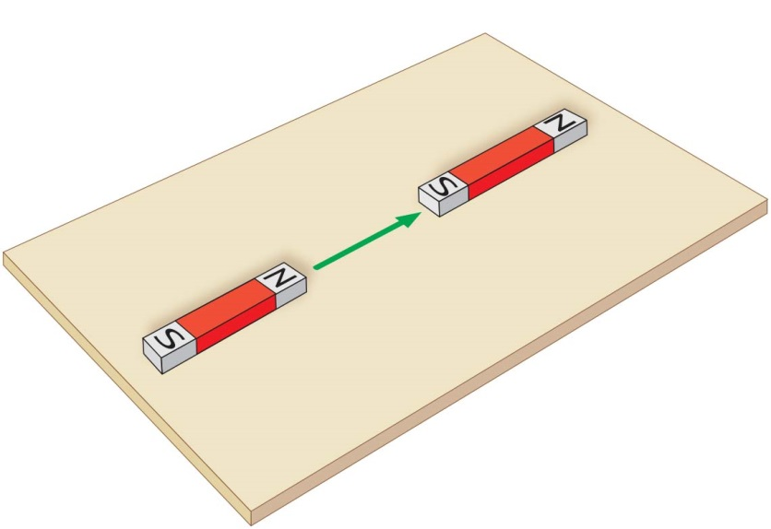

Repulsion

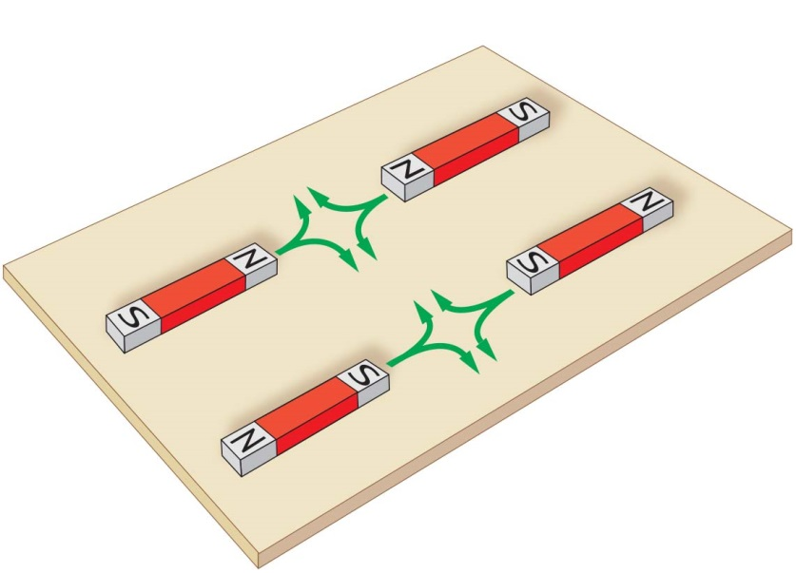

WORD DETECTIVE

3 Draw and label

Use the words below to label a simple sketch of Maglev used for trains.

Student responses will vary, but the diagram should show a series of magnets on the Maglev (magnetic levitation) train and track that have like poles. Because these magnets have like poles, they repel, causing the train to float above the track. Because there is no contact between the train and surface of the metal track, there is no friction. In addition to attracting magnetic metals, magnets can also attract alloys, such as steel.

7.4 Magnetic fields can apply a force from a distance

Literacy support worksheet answers (pages 126–127)

Magnetic fields

1 Iron filings are scattered around a bar magnet below, to show the magnetic field.

a Why do you think iron filings were used to show the magnetic field instead of something bigger like a steel bar?

Iron filings were used because they are magnetic and also very small or fine, so are attracted to the magnetic fields.

b Magnetic field lines should point away from the north pole of the magnet and towards the south pole of the magnet. Draw a map of the magnetic field lines on the second magnet.

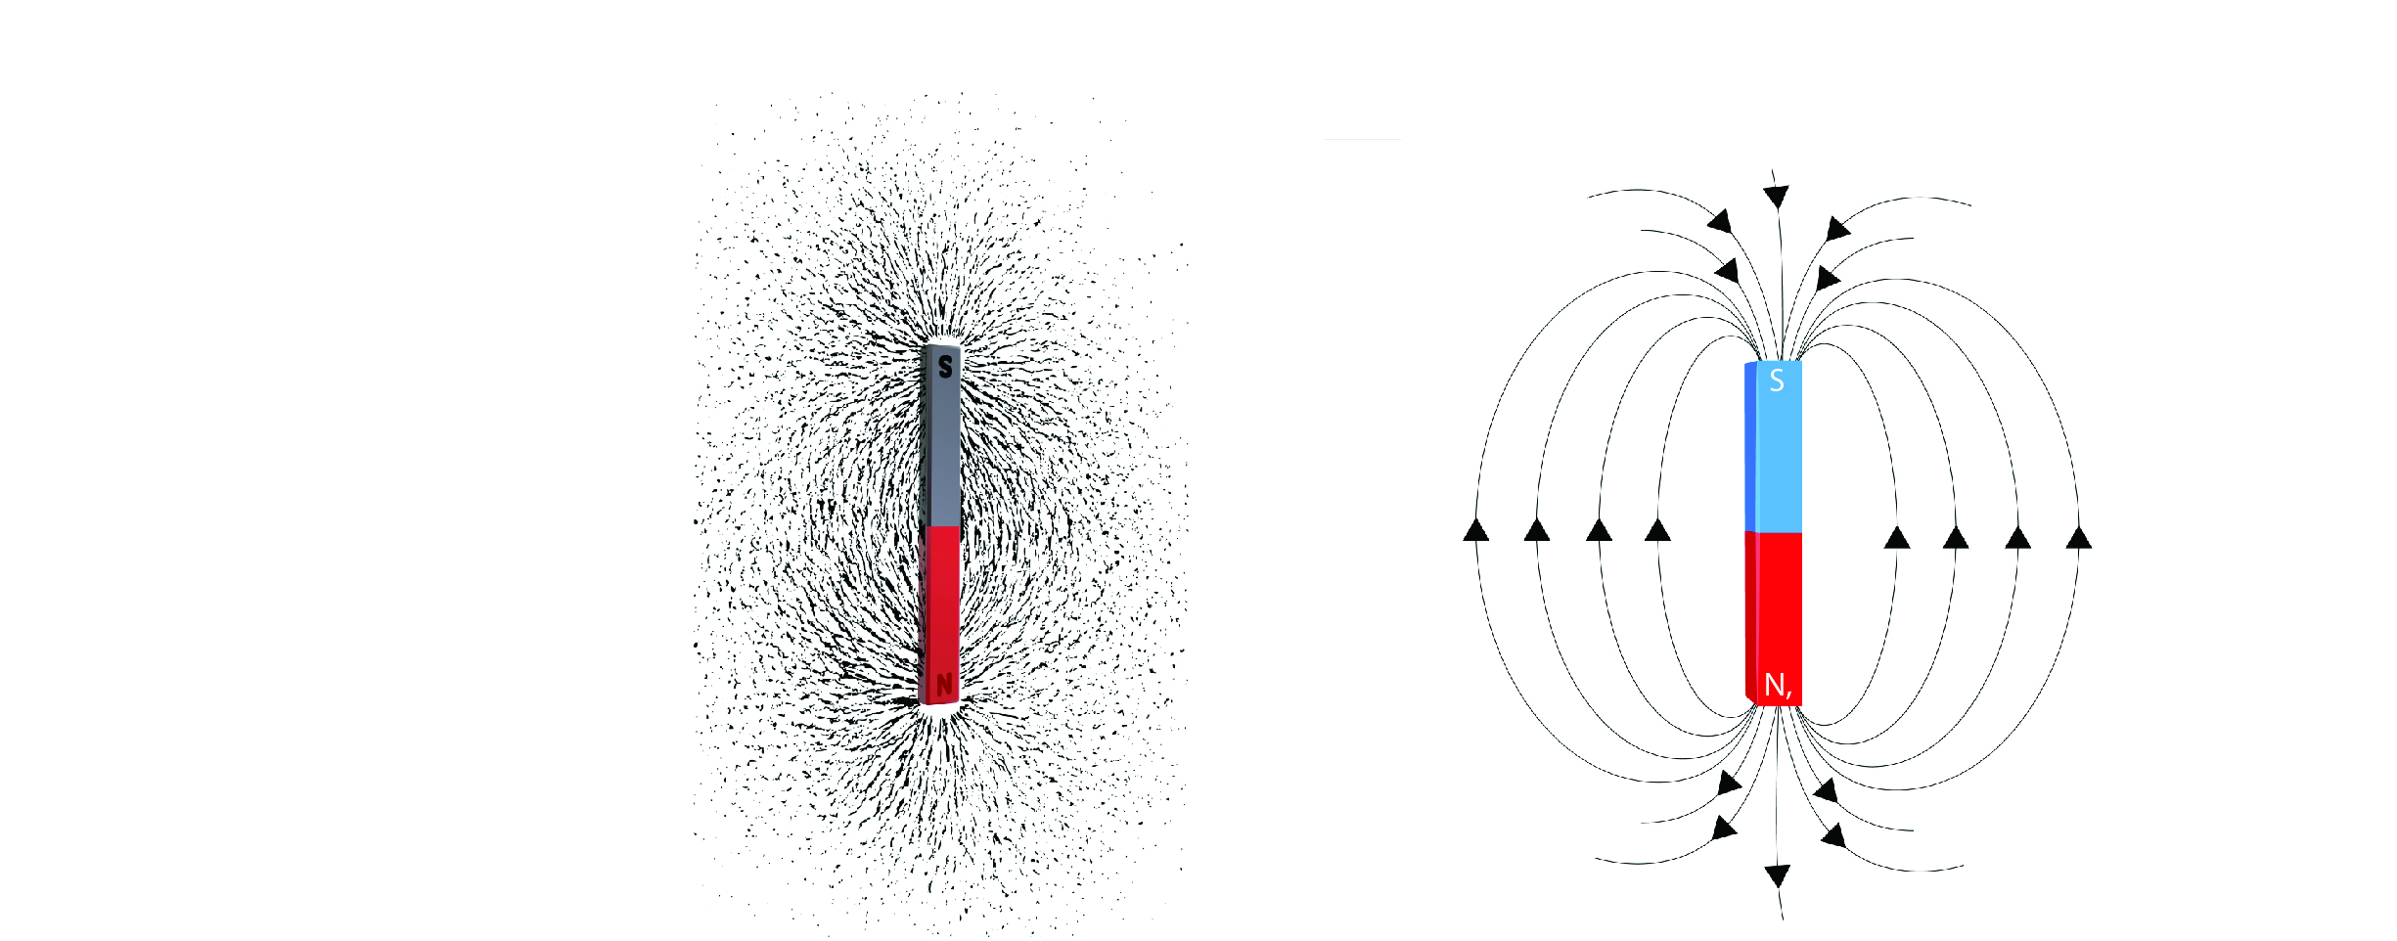

c Draw a map of the magnetic field lines on the magnet below, which is the other way around.

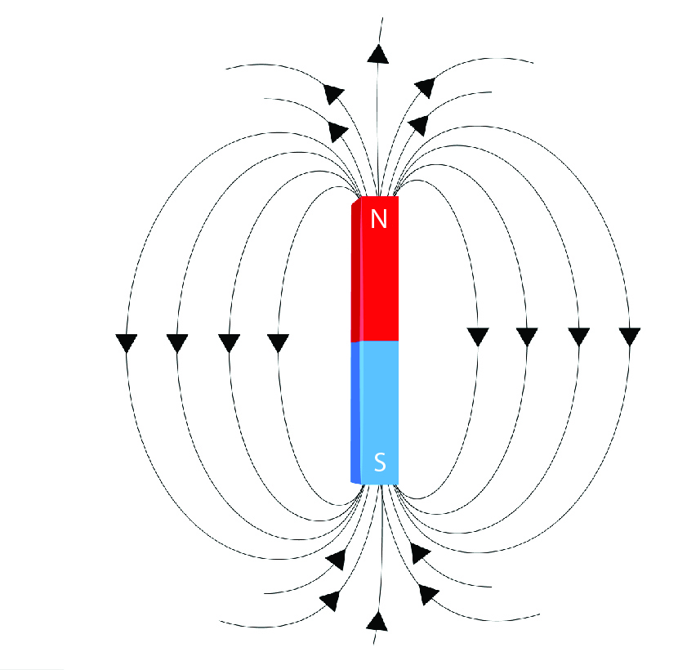

2 The Earth is like an enormous magnet with its own north and south poles.

Draw magnetic field lines on the diagram of the Earth below.

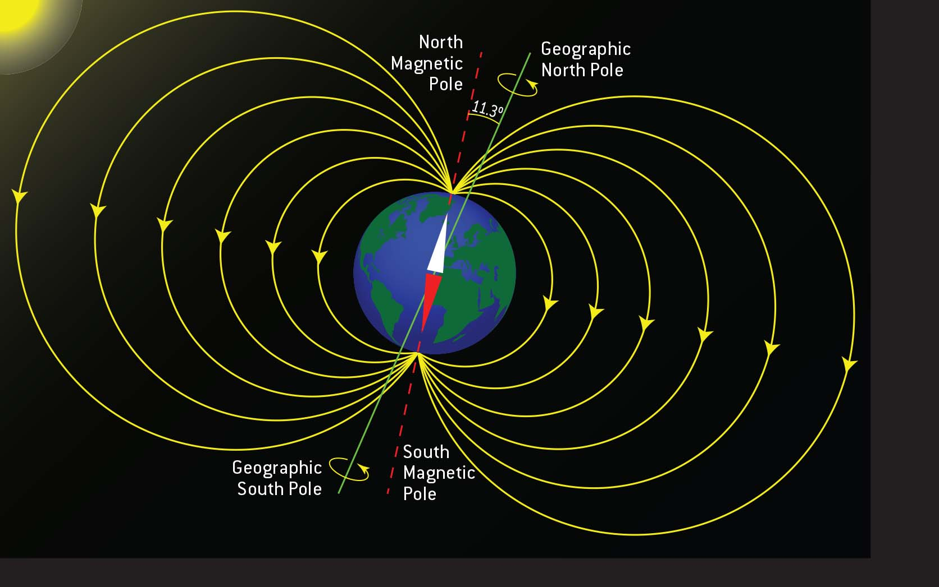

WORD DETECTIVE

3 Fill in the blanks

Fill in the gaps using magnetic field information.

The Earth is like a giant magnet with north and south poles. It is surrounded by a magnetic field that extends way beyond the Earth’s atmosphere called the magnetosphere. Many animals use the magnetic field of the Earth like a compass to navigate their way. Scientific research has found that birds use the Earth’s magnetic field when migrating.

These days we now know that many animals use the Earth’s magnetic field to navigate. Snails, fruit flies, bees, butterflies, salamanders, newts, lobsters, frogs, bats, salmon, trout, whales, sea turtles and the mole rat of East Africa can, too. There is some evidence to suggest that humans have magneto-sensing abilities too.

7.5 Electrostatic forces are non-contact forces

Literacy support worksheet answers (pages 128–129)

Static electricity

1 With charged objects, the rules: ‘opposites attract’ and ‘like repels like’ can be used.

In each of the situations below, write whether the objects will: *attract, repel* or *do neither*.

a Two negatively charge objects:

Repel

b Two positively charged objects:

Repel

c A positively charged object and a negatively charged object:

Attract

d A positively charged object and a neutral object:

Attract

e A negatively charged object and a neutral object:

Attract

f Two neutral objects:

Do neither

2 Use the words below to complete the following sentences about electrostatic charges.

When objects are rubbed they become charged because they have lost or gained negative charges or electrons. If they are placed near neutral objects (which have equal or balanced positive and negative charges) they will be attracted to the positive or negative charges and will move towards that object. This attraction or electrostatic force due to charges is called static electricity.

3 Using the space below, draw a sketch of yourself touching a Van de Graaff generator. Add labels to the diagram, including:

• the negatively charged electrons travelling from you to the dome

• the negative charges on the dome attracting neutral objects like paper

• each positively charged hair repelling the next one, making it stand on end.

The diagram should be a self-portrait (simple to complete depending on the student’s artistic ability) and should show their hair standing on end. Charges on the dome come from the build up of static electricity. These negative charges are attracted to neutral objects due to electrostatic force. Hair stands on end because each hair has a negative charge, therefore repels.

WORD DETECTIVE

4 Word search

Find as many words as possible in the puzzle below.

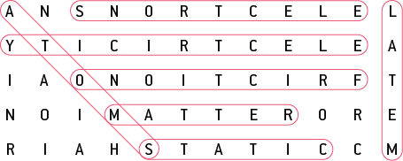

7.6 Friction slows down moving objects

Literacy support worksheet answers (pages 130–131)

Friction

1 Use the words below to fill in the gaps.

Friction is a contact force. It works when the surface of one object rubs against the surface of another object. The greater the area of contact between surfaces, the greater the friction. Friction acts in the opposite direction to movement. The smoother or rougher the surface, the more/less friction there is and the more or less an object can move. Friction can generate heat when objects are moving: the greater the friction, the greater the heat made.

2 Give an example of a situation where *reducing* friction is an advantage.

Student responses will vary, but should include a situation where heat, reduced movement or wear occurs, such as an ungreased bicycle chain, streamlining a car or making a larger sail on a boat.

3 Give an example of a situation where *increasing* friction is an advantage.

Student responses will vary, but could include putting on the breaks in a car to slow it down or digging your feet into the ground to prevent slipping.

4 Study the diagrams of different surfaces. Rank the surfaces from 1 (least frictional force) to 4 (most frictional force).

Carpet: 3

Rocks: 4

Ice: 1

Wet grass: 2

5 Scientists are still unable to explain how the pyramids in Egypt were built because of the weight of the heavy boulders. Explain one method you could use to reduce friction and *push* a heavy boulder across the ground.

Student responses will vary, but should include methods to reduce friction, such as lubricating the boulder or the ground, putting wheels or rollers under the boulder and applying more force (e.g. having more people pushing or pulling).

WORD DETECTIVE

6 Match-a-word

Draw a line from the words to their meanings.

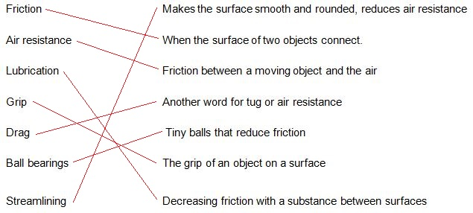

7.7 Simple machines decrease the amount of effort needed to do work

Literacy support worksheet answers (pages 132–133)

Simple machines

The Ancient Egyptians developed simple machines to help them with building the pyramids.

1 The picture below shows the Ancient Egyptians using different types of levers. Write which materials are being used as levers and how.

The piece of wood combined with the wheels provides the fulcrum, the cart is the load and the animals pulling the cart are the effort. Combined, this is a first- class lever.

2 Below are diagrams of the three classes of lever. For each diagram:

• identify the class of the lever

• label the fulcrum, load and the direction of the effort

• draw an example (different from those in the textbook) of this type of lever.

a

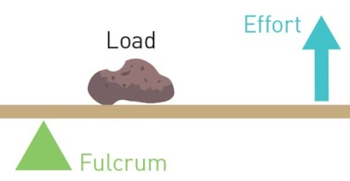

This is a second-class lever. Students may provide different examples of second-class levers, but one example is a see-saw.

b

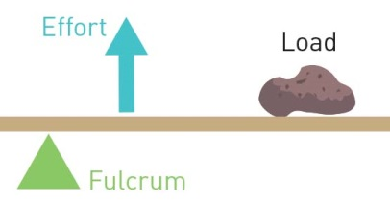

This is a third-class lever. Students may provide different examples of third-class levers, but one example is a bottle opener.

c

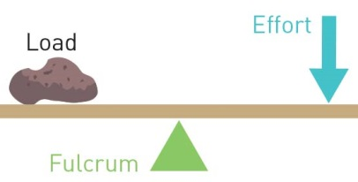

This is a first-class lever. Students may provide different examples of first-class levers, but one example is a pair of tweezers.

3 A lever can give you a mechanical advantage. The size of the advantage can be calculated by dividing the size of the load by the size of the effort:

Example: A wheelbarrow has a 3 N load and needs 1 N effort to lift it.

What is the mechanical advantage of the wheelbarrow?

$$\text{Mechanical advantage = }\frac{\text{size of the load}}{\text{size of the effort}}$$

$\text{= }\frac{\text{3}}{\text{1}}$

= 3

a A boulder has a 10 N load and needs 5 N of effort to move it using a lever. What is the mechanical advantage of the lever?

Mechanical advantage = 10/5 = 2 N

b A nail had a 9 N load of resistance and needs 3 N of effort using a hammer to remove it. What is the mechanical advantage of the hammer?

Mechanical advantage = 9/3 = 3N

WORD DETECTIVE

4 Word search

Find the words listed, in the puzzle below.

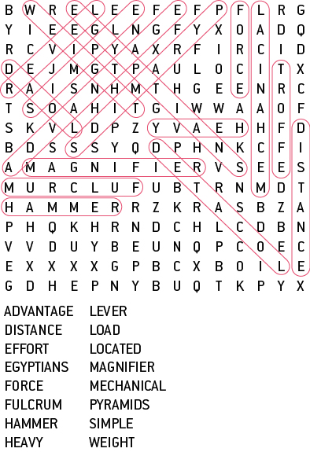

7.8 A pulley changes the size of direction of force

Literacy support worksheet answers (pages 134–135)

Pulleys

The pictures show pulley systems helping a person lift bigger loads.

1 Fill in the missing information in each picture. Part (a) has been done for you as an example.

D = how far the mass would be raised

F = the force required

L = the length of the rope

M = the mechanical advantage

a

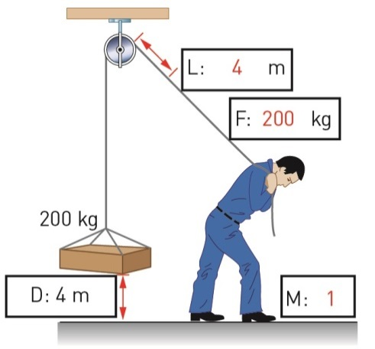

b

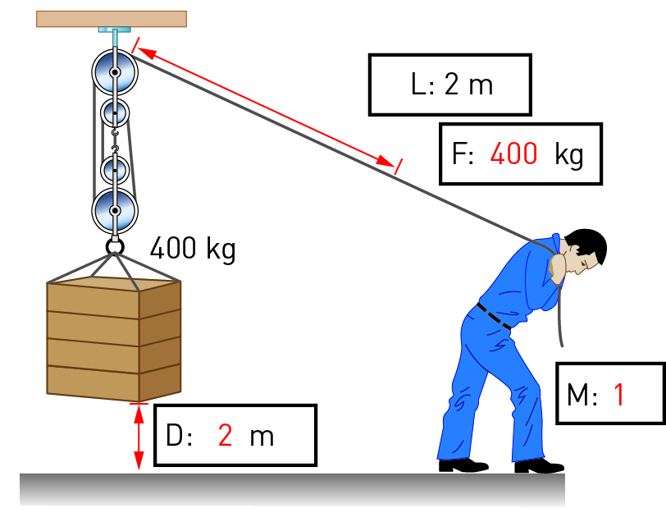

c

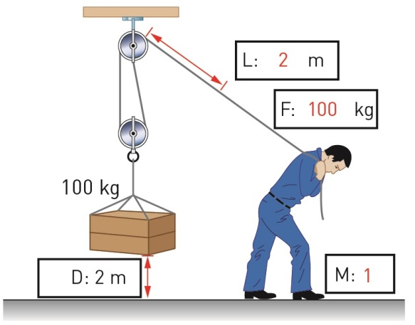

d

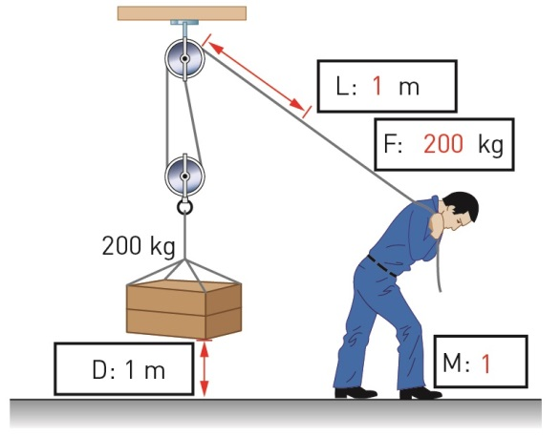

WORD DETECTIVE

2 Secret message

Use words from the student book to work out the secret message below:

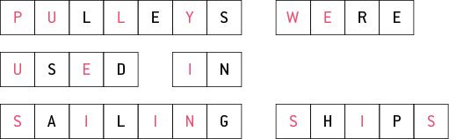

7.9 There are different types of machines

Literacy support worksheet answers (pages 136–137)

Types of machines

1 Look at the ramps in the two images below.

Which ramp do you think would take the least amount of effort to walk up? Explain your answer.

The ramp in the left-hand image would take the least amount of effort to walk up. The slope of the ramp in this image is less steep than the slop of the ramp in the other image.

2 How do your front teeth (incisors) act as a wedge when you bite into a carrot or an apple?

The front teeth act as two inclined surfaces that split the food, allowing a piece to be bitten off.

3 There is a saying ‘righty tighty, lefty loosey’. Which direction would take more effort to turn the screw, ‘clockwise’ or ‘anti-clockwise’?

As the screw is turned to the right (clockwise), it is forced into the wood; thus, more effort is required and the screw becomes tighter. As the screw is turned to the left (anti-clockwise), it becomes looser.

4 Label the following features on the diagram:

• wheel (the lever)

• axle (links the fulcrum to the wheel)

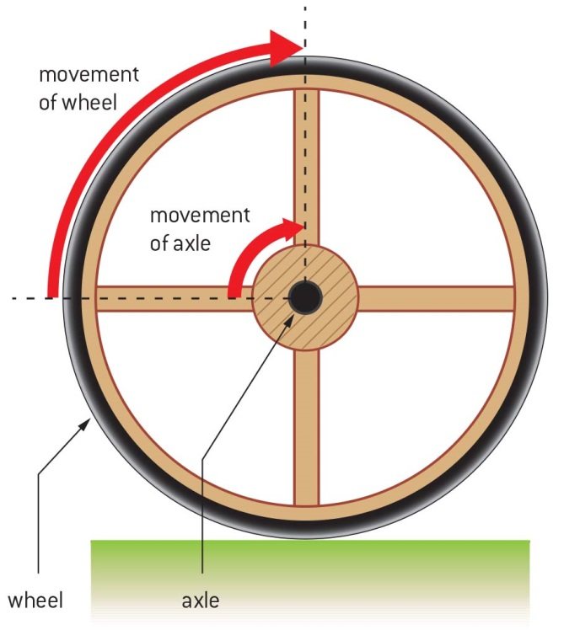

5 A wheel is a distance multiplier. On a bike, the smaller pedal in the middle would turn, causing the larger outside wheel to turn.

How does the size of the wheel increase the distance travelled?

The larger the wheel, the larger the distance the wheel travels.

WORD DETECTIVE

6 True or false?

Read each statement below and circle T if it is true or F if it is false.

a A screw is an inclined plane

T

b Going up stairs takes less force off your legs than a ramp

T

c The outside edge of a wheel moves a larger distance than its axle

T

d The distance travelled by a pedal on a bike is greater than that of the wheel

F

e A wedge changes the direction of a sideways force to a downwards one

F

f A ramp is a simple machine

T

7.10 Science as a human endeavour: Forces are involved in sport

Literacy support worksheet answers (pages 138–139)

Forces in the body and sport

Forces in swimming

1 What is the most efficient body position for a swimmer?

A swimmer’s body is most efficient in a straight, streamlined position.

2 List the features of the full-body ‘smart suits’ that provided an advantage to the swimmers wearing it.

• The material repelled water

• The smart suit is lighter for the swimmer to wear

• The smart suit reduced friction between the swimmer and the water

Forces in tennis

3 Label the parts of the tennis player’s body that provide the: fulcrum, effort and load.

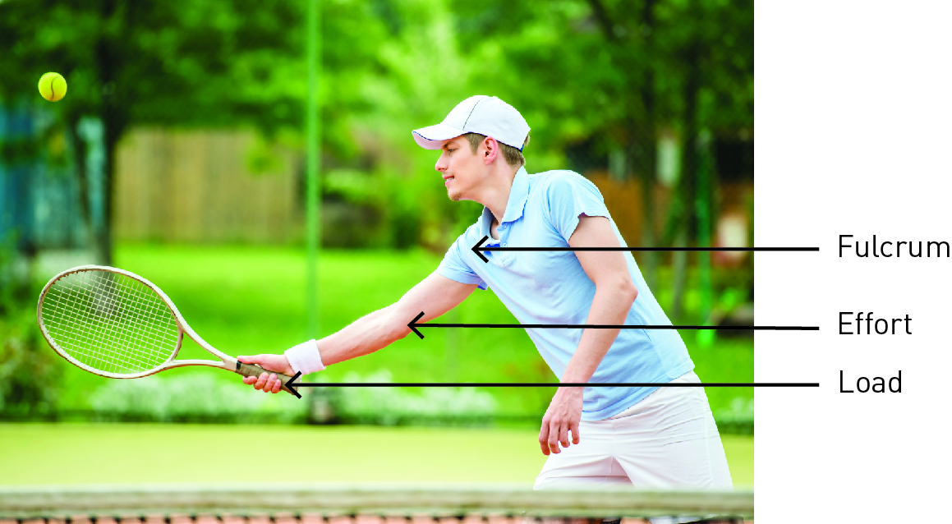

4 What kind of lever is a tennis racquet?

A tennis racquet is a third-class lever

5 How does a longer tennis racquet help?

A lighter and longer tennis racquet increases the speed and force at which the player can hit the ball.

Forces in golf

6 Label the diagram below to help explain why golf balls have dimples.

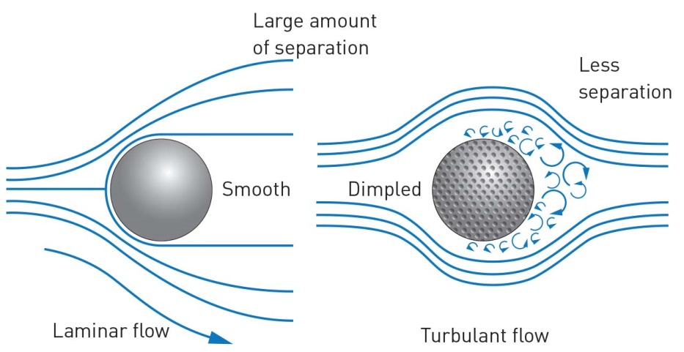

WORD DETECTIVE

7 Crossword

Revise your knowledge of the Forces chapter by reading the clues below and placing the correct answers in the crossword boxes.

